ARTiculate Change
🎨Artivism 🎭
06.10. – 15.10.2025 | Trnava, Slovakia

In a world facing complex social, political, and environmental challenges, artivism – the fusion of art and activism – has emerged as a tool to inspire action, strengthen voices, and build resilient communities.

This training invites you to become an artivist: someone who uses creativity to fight injustice, raise awareness, and spark transformation through visual storytelling, performance, and intercultural collaboration.

🔍 What Is This Training About?

Over the course of 10 days (including two travel days), you will dive into the world of artivism, exploring how artistic practices can be used to engage communities, promote human rights, address social issues, and change the world around you.

Also, you will experiment with creative tools and collective processes that help translate passion into purpose – and art into action.

🎯 Themes of the Training

Welcome, future changemakers!

Through hands-on workshops, team missions, and collaborative artmaking, you will explore how to:
• Use art as a tool for activism, advocacy, and social change;
• Tell powerful stories through visual, digital, or performance-based mediums;
• Explore themes like justice, identity, climate, and equality through art;
• Engage diverse audiences in public space and online;
• Collaborate across cultures to co-create impactful artistic projects.

Together, we will explore how artivism turns creativity into resistance – and how YOU can become a creative force in your community.

✨ What You Will Learn (Objectives)

By the end of this training, you will be able to:
• Understand the role of artivism in social movements and civic engagement;
• Apply artistic methods (e.g., visual arts, storytelling, performance) to raise awareness on key issues;
• Design and implement your own creative advocacy projects;
• Develop your skills in storytelling, design, and creative communication;
• Work collaboratively across cultures in inclusive, co-creative environments;
• Use gamification and creative media for education and outreach;
• Strengthen your confidence in using art as a catalyst for dialogue and change;
• Build international networks for future Erasmus+ projects and collaborations.

🎨 Methodology: Learning by Creating

This is not your typical training.

ARTiculate Change is a journey that blends:
• Artistic workshops (visual arts, digital media, performance);
• Storytelling and creative communication sessions;
• Gamified learning challenges to engage with real-world issues;
• Intercultural dialogue and community-based co-creation.

Through the project, participants will develop their own artivist projects – using creative expression to address topics and issues they care about.

🌍 Who Can Join?

We welcome participants who are:

- Youth workers, educators, creatives, or activists aged 18+;
- Motivated to engage in social and cultural issues;
- Ready to take part in the full training;
- Open to international cooperation;
- Comfortable communicating in English.

💡 Why Artivism?

- Because activism does not have to be loud to be powerful.
- Because brushes and words can be tools of resistance.
- Because creativity can heal, connect, and transform.

Join us in Trnava for a unique opportunity to learn, create, and act – where art becomes activism, and activism becomes art.

Eligible countries: Slovakia, Romania, Turkey, Czech Republic, Hungary, Ireland

Applicant organisation: Bratislava Policy Institute (BPI) is an independent not-for-profit think tank dedicated to fostering liberal democracy, human rights, Central European region, and European integration through analysis and debate, supporting and challenging relevant stakeholders at national and international levels to make informed decisions based on evidence and analysis.

The food and accommodation will be provided and paid by the organisers. Travel costs will be counted based on the distance calculator of the European Commission and reimbursed by bank transfer after the course (in EUR) through the sending organisations.
Maximum travel cost according to distance calculator:

- Slovakia – 0 EUR (4 participants) – travel will be reimbursed if a participant travels more than 5 km
- Romania – 309 EUR (5 participants) – green travel 417 EUR
- Ireland – 309 EUR (4 participants) – green travel 417 EUR
- Turkey – 309 EUR (5 participants) – green travel 417 EUR
- Hungary – 211 EUR (4 participants) – green travel 285 EUR
- Czech Republic – 180 EUR (4 participants) – green travel 210 EUR

What to bring with you?

- Your passport or ID card
      - All your travel tickets!!! (it is very important to keep all your tickets, receipts, and boarding passes, because we can give you back the travel costs only if you have the tickets)
      - National snacks, drinks, easy food, specialties, local music for the cultural evening
      - Medicines - if you need them (anti-allergy pills, pain killers, Aspirin etc.)
      - Laptop, camera – it is not obligatory, but it can be useful

Weather

Before leaving your home country, please check the weather forecast at:
https://www.meteo.sk/

Usually, the weather is colder in October.

Accommodation

The accommodation will be provided in Penzión na Mlyne, Trnava (close to the small town Trnava and to the capital Bratislava). The daily activities will take place at the same place. Food will be arranged by the organisers, there will be three meals every day: breakfast, lunch and dinner; and coffee breaks.

You can find the hotel website here: https://www.namlyne.sk/
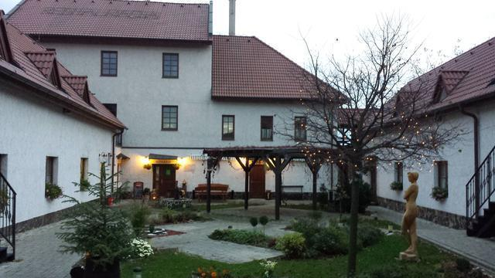
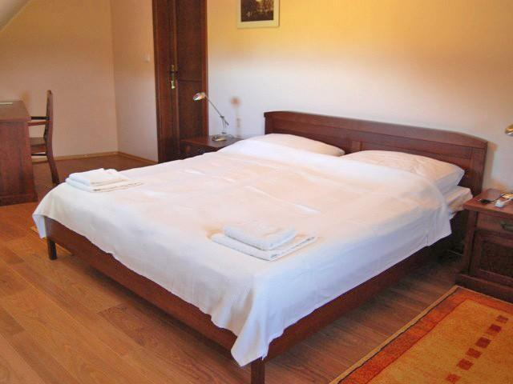

How do you reach Trnava?

BRATISLAVA AIRPORT (BTS)
There are direct flights from several destinations in Europe and many airlines that operate their direct routes to Bratislava – RYANAIR, Pobeda, Flydubai, Smart Wings, Air Cairo, Wizz Air. To get to Trnava from Bratislava airport you can take a bus no. 61 to Main Train Station (Hlavná stanica). From there, you can take a train to Trnava main station. Bus tickets for no. 61 are available in ticket machines at bus stops or in kiosks (or in the mobile app). Train tickets can be bought directly at the train station. The tickets for the bus no. 61, which cost around 1,20 EUR, must be validated on the bus. Please let us know the approximate time when you arrive in Trnava, we will sort out transportation to the hotel from there.

VIENNA-SCHWECHAT (VIE) AIRPORT
The airport at Vienna-Schwechat is only 40 kilometres west of Bratislava and Slovaks mainly use it for long-haul flights. It is one of the main gateways to Slovakia. Buses to Bratislava depart at 30 to 60-minute intervals. Tickets can be bought on the bus; check the following companies: eurolines.sk, regiojet.com, flixbus.com to Autobusová stanica, Bratislava. You can take a bus to Trnava from there.

BY TRAIN
Bratislava is connected to the main lines from Prague, Budapest, Vienna, and various regions in Slovakia. Bratislava has many railway stations; however, you can take a train to Trnava from The Main Train Station.

BY BUS
Bratislava is also conveniently connected with many European cities via a network of bus lines. It has frequent services to the surrounding areas and to other regions in Slovakia. Buses arrive and depart from Autobusová stanica, Bratislava. Coaches between Bratislava and Vienna run at one-hour intervals: eurolines.sk, regiojet.com, flixbus.com. You can take the bus to Trnava from Autobusová stanica, Bratislava.

BY BOAT
Due to its position on the river Danube, Bratislava has regular connections by boat to and from Vienna. The centre of Vienna (Schwedenplatz) is connected to Bratislava by a fast catamaran Twin City Liner and another fast hydrofoil, which is berthed at Vienna Handelskai.

BY CAR
Bratislava is situated at the intersection of several important motorways. The distance to Prague is 330 km, Budapest 200 km and Vienna 65 km. If you bring your own car, you need to display a valid motorway tax sticker (known as “diaľničná známka”), available at borders or petrol stations. The minimum validity period is 10 days (costs around 10 EUR). Trnava is approximately 30 minutes from Bratislava and the easiest to get there is through the highway.

If you have any questions, please feel free to contact us on wagingerova@bpi.sk

 | Day 0  06.10.  Monday | Day 01  07.10.  Tuesday | Day 02  08.10.  Wednesday | Day 03  09.10.  Thursday | Day 04  10.10.  Friday | Day 05  11.10.  Saturday | Day 06  12.10.  Sunday | Day 07  13.10.  Monday | Day 08  14.10.  Tuesday | Day 09  15.10.  Wednesday
08:30  -  09:30 |  | Breakfast | Breakfast | Breakfast | Breakfast | Breakfast | Breakfast | Breakfast | Breakfast | Breakfast
09:30  -  11:00 | Arrival of Participants | Get to Know Each Other/ Ice Breaking Activities | Active Participation 101 | The Art of Storytelling | Workshop  Sestry Jančové (TBC) | Study Visit | World Café Discussion (Illusion of Understanding) | Setting up Plan | Final Touches | Departure of  Participants after Breakfast
11:00  -  11:30 | Arrival of Participants | Coffee Break | Coffee Break | Coffee Break | Coffee Break | Coffee Break | Coffee Break | Coffee Break | Coffee Break | Departure of  Participants after Breakfast
11:30  -  13:00 | Arrival of Participants | Introduction to the Mobility's  Aim and Goals  -  Day-by-Day Programme – House Rules | Artivism 101 | Storytelling and Artivism  -  Practical Workshop | Workshop Sestry Jančové (TBC) | Study Visit | Digital Artivism | Preparation for Exhibition | Final Presentation  of Group Work (Baterkáreň) | Departure of  Participants after Breakfast
13:00  -  15:00 | Arrival of Participants | Lunch | Lunch | Lunch | Lunch | Packed Lunch/ Lunch in the City | Lunch | Lunch | Lunch | Departure of  Participants after Breakfast
15:00  -  16:00 | Arrival of Participants | Non-Formal Education  Erasmus+ Programme  -  Youthpass | Trashart – or How to Create from Garbage | Kafé Lampy  -  Study Visit (Gallery and Coffee)  How Does It Work? | Theatre of the Oppressed -  Methodology for Youth Work | Free Afternoon with Several Options | Digital Artivism  -  Practical Workshop | Presenting the Draft  -  Preparation for Exhibition | Final Presentation  of Group Work (Baterkáreň) | Departure of  Participants after Breakfast
16:00  -  16:30 | Arrival of Participants | Coffee Break | Coffee Break | Really Good Coffee Break | Coffee Break | Coffee Break | Coffee Break | Coffee Break | Coffee Break | Departure of  Participants after Breakfast
16.30  -  18:00 | Arrival of Participants | Preparation for Intercultural Night | Trashart – or How to Create from Garbage | Kafé Lampy  -  Study Visit (Gallery and Coffee)  How Does It Work? | Theatre of the Oppressed -  Theatre simulation | Free Afternoon with Several Options | Murial Workshop | Presenting the Draft  -  Preparation for Exhibition | Fill in the Youthpass Certificate – Dialogue Space  +  Evaluation of the Mobility | Departure of  Participants after Breakfast
19.00  -  20:00 | Dinner | Dinner | Dinner | Dinner in Kafé Lampy | Dinner | Dinner | Dinner | Dinner | Dinner | Departure of  Participants after Breakfast
20:00 | Informal Evening | Intercultural Night | Free Evening | Free Evening | Free Evening | Free Evening | Free Evening | Free Evening | Goodbye  Party | Departure of  Participants after Breakfast

